Technical writing about Camlin Geometry Box:
The following are the specifications of CamlinTM Scholar Mathematical Drawing Instrument Box:
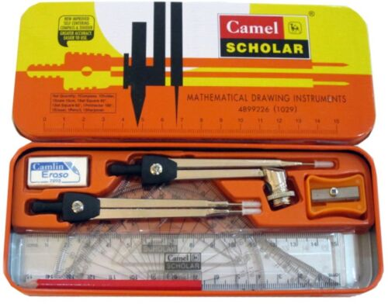
S.no. | Components | Qty(in no.s) | Size / Dimensions | Material | Use | Remarks (if any) | Image
1 | Compass | 1 | 10 cm long | Stainless steel arm with black colour plastic holder , plastic cap for tip of arm | For drawing circles, | Improved , self centering with Camlin logo, greater accuracy | 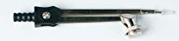
2 | Divider | 1 | 10 cm long | 2 Stainless steel arms with black colour plastic holder , plastic cap for tip of arms | For measuring and marking length | Improved , self centering, with Camlin logo, greater accuracy | 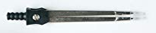
3 | Scale | 1 | 15cm | Transparent, plastic | For measuring and marking length | Both sides of scale marked in cm, with Camlin logo, greater accuracy | 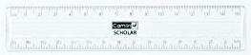
4 | 90º Set Square | 1 | Angles -90º,60º,30º, scale of 11cm and 7 cm | Transparent , plastic | For measuring angles and marking length | with Camlin logo, greater accuracy | 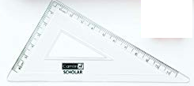
5 | 45º Set Square | 1 | Angles -90º,45º,45º, scale of 9cm on two of the sides | Transparent , plastic | For measuring angles and marking length | with Camlin logo, greater accuracy | 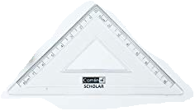
6 | Protractor | 1 | 180^{O} inner and outer angles | Transparent , plastic | Measuring angles | with Camlin logo, greater accuracy | 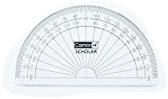
7 | Sharpener | 1 | 2cmx2cmx 1cm | Plastic, Orange colour with sharp stainless steel blades | Easy and safe sharpening of pencils | With Camlin logo, easy to use | 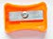
8 | Pencil | 1 | 8cm | Wooden with red colour | Writing , drawing, to be fixed in compass | With Camlin logo, greater accuracy | 
9 | Eraser with cover | 1 | 2cmx2cmx 1cm | Eraser: White ,rubber; Cover: white, paper | Erases pencil marks | With Camlin logo, easy to rub | 

Creative writing about Camlin Geometry Box:

My Introduction to a Instrument box

My son called out to me “Mom, could you please help me with the construction, the final measurements are not right”. I pulled out the chair next to him and read the question, then - something crossed my mind. I too had practiced similar questions during my school days. My eyes were caught on the orange geometry box which he had kept open. I still remember the day when Mrs. Sundari, my Math teacher had announced “All of you should bring your geometry box to class on Wednesday”. After school I went home and broke the “NEWS” to my mother.

That day I got my first geometry box- A “Camlin Scholar Mathematical Drawing Instrument Box”- an orange box which made a clang as I shook it. The curious cat in me told me to open the box as soon as I reached home. I found some new instruments in that which was very unusual. I could recognize the red wooden pencil, the typical orange sharpener, the eraser with a protective cover and a plastic scale. I wondered what the triangles, semicircles and two sturdy sharp metal objects were for.

It was Wednesday; I took my geometry box to school. Mrs. Sundari came to our class. She asked us to open page no. 169 of our Math text book and also to keep our geometry box open. She asked us to take out the metal object which had one arm - she taught from the text book that it is called a “Compass”. I noticed that it had a pointed tip. She also showed us how to insert a pencil into a compass and tighten it. It was so easy and we could draw a circle very accurately because of the sharp tip. I was not sure where to insert the pencil for the other metal instrument. That’s when the teacher explained that it had a different purpose, i.e. to measure the length between two points.

I read about the next two instruments from text book even before the teacher could finish about the “Divider”. She took out two triangular instruments and asked if any of us could explain about them. I raised my hand and blurted out that those were the “Set Squares” and they were used to measure the angles. The class clapped for me and I sat down proudly. The teacher was about to explain something that’s when the principal’s assistant came and gave her a circular. The teacher read the circular and the assistant left the class.

One of my fellow peer thought that the teacher forgot to explain about the last unfamiliar instrument in the box. She raised her hand and said Ma’am, you forgot about the semi- circular transparent instrument”. She questioned us whether we were confused on why there were markings 0 to 180 from both left to right and from right to left. One of my classmate guessed that it was to measure the angles from both the sides but he was not aware that he was talking about the “Protractor”. As I looked at my son’s geometry box, I had a deep understanding that the “Camlin Scholar Mathematical Drawing Instrument Box” is one of the most trusted instrument boxes which still has place holder in a student’s life.

